**Dwarf Buckwheat Life Cycle Plates**

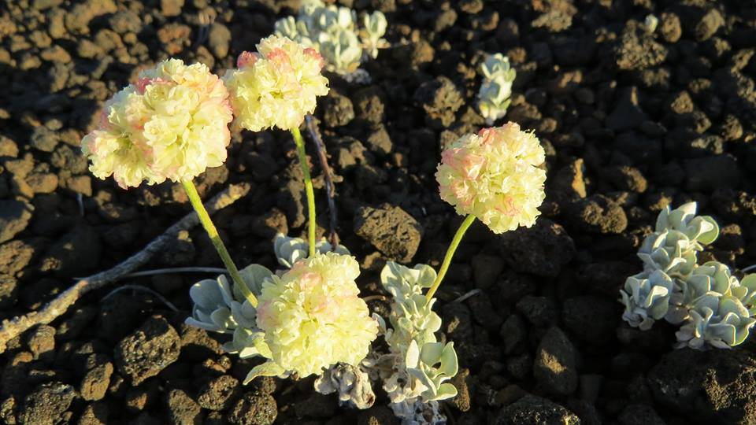

Background Info:

The leaves of dwarf buckwheat are low to the ground and usually measure less than ½ inch in length. These tiny leaves are covered with woolly white hairs which protect the plant from losing too much water in the hot sun. This is an important adaptation because the surface temperature of the black cinder fields where these plants grow can reach 150°F or more! The plants form mats or clusters that are usually evenly spaced. The roots spread outwards to collect as much water as possible while helping to hold loose soil together. In late spring and early summer, the pom-pom shaped flowers bloom in yellow, pink, or orange and turn red as time goes on. Park biologists think that a species of silver-blue butterfly plays an important role in pollenating the flowers, but many other insects like bees and wasps visit the flowers when they are in bloom. Prospectors and miners thought that this plant indicated the presence of silver ore, so they called it “silver plant.” Although buckwheat is one of the largest groups of plants in North America, this species (*Eriogonum ovalifolium* var. *focarium*) is unique to Craters of the Moon.

Materials:

* Paper plates
* Life Cycle of the Dwarf Buckwheat printouts
* Construction paper with a circle missing a slice printed or drawn on it
* Paper fasteners
* Glue
* Scissors
* Colored pencils or markers

Directions:

**Step 1:** Color the dwarf buckwheat life cycle printouts. Cut out both the life cycle and the label.

**Step 2:** Glue the life cycle onto the back of a paper plate.

**Step 3:** Cut out a construction paper circle with a slice in it. Glue the “Life Cycle of the Dwarf Buckwheat” label onto the construction paper circle opposite the slice.

**Step 4:** Place the construction paper circle on top of the life cycle. Stick a paper fastener through the middle of both paper circles and the paper plate.

Hold the construction paper and rotate the paper plate counterclockwise to view the stages in the life cycle of the buckwheat.

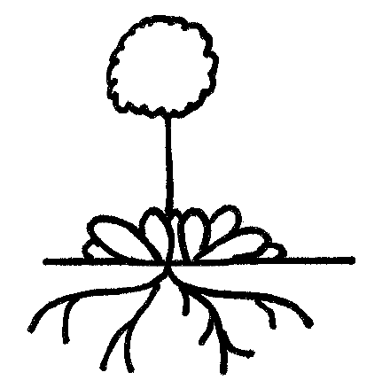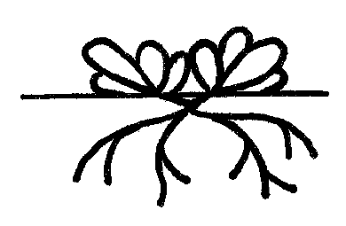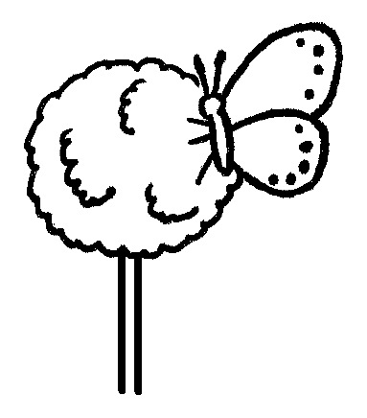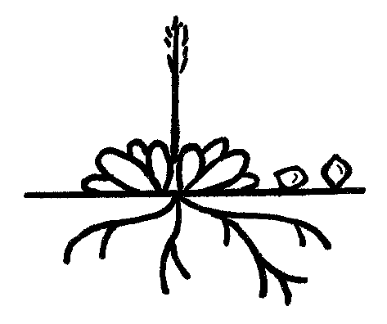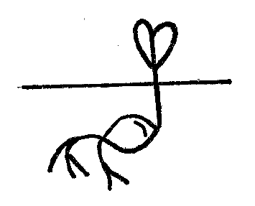

Life Cycle of the Dwarf Buckwheat

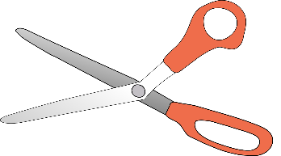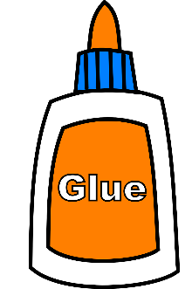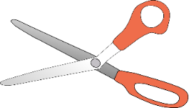

Life Cycle of the Dwarf Buckwheat



Life Cycle of the Dwarf Buckwheat

paper fastener



Life Cycle of the Dwarf Buckwheat